Dalson CPO Testing Report

1. CPO 22
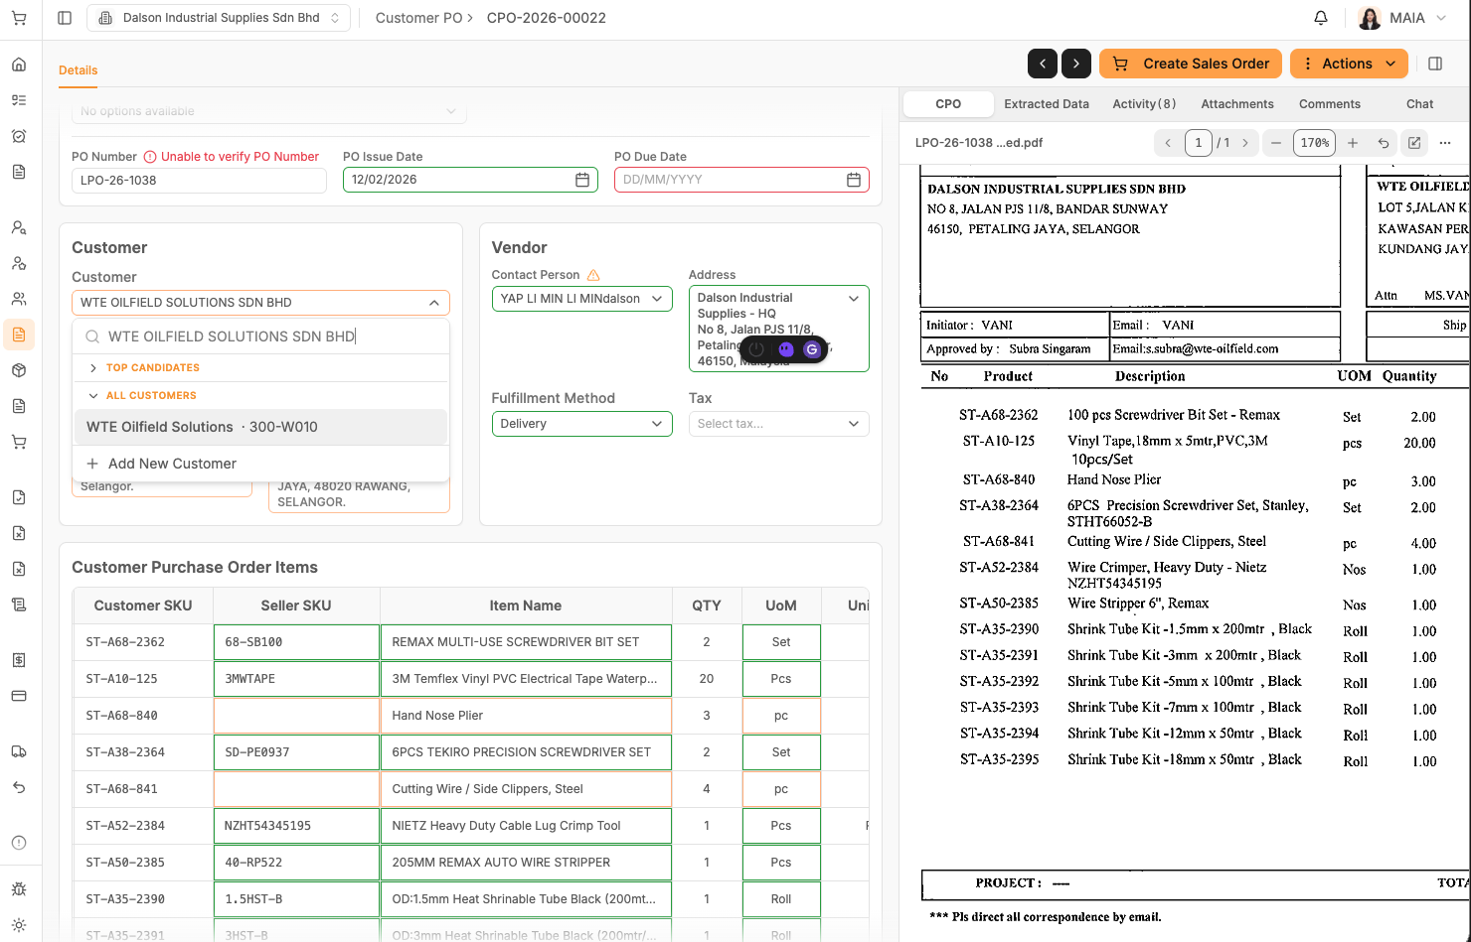
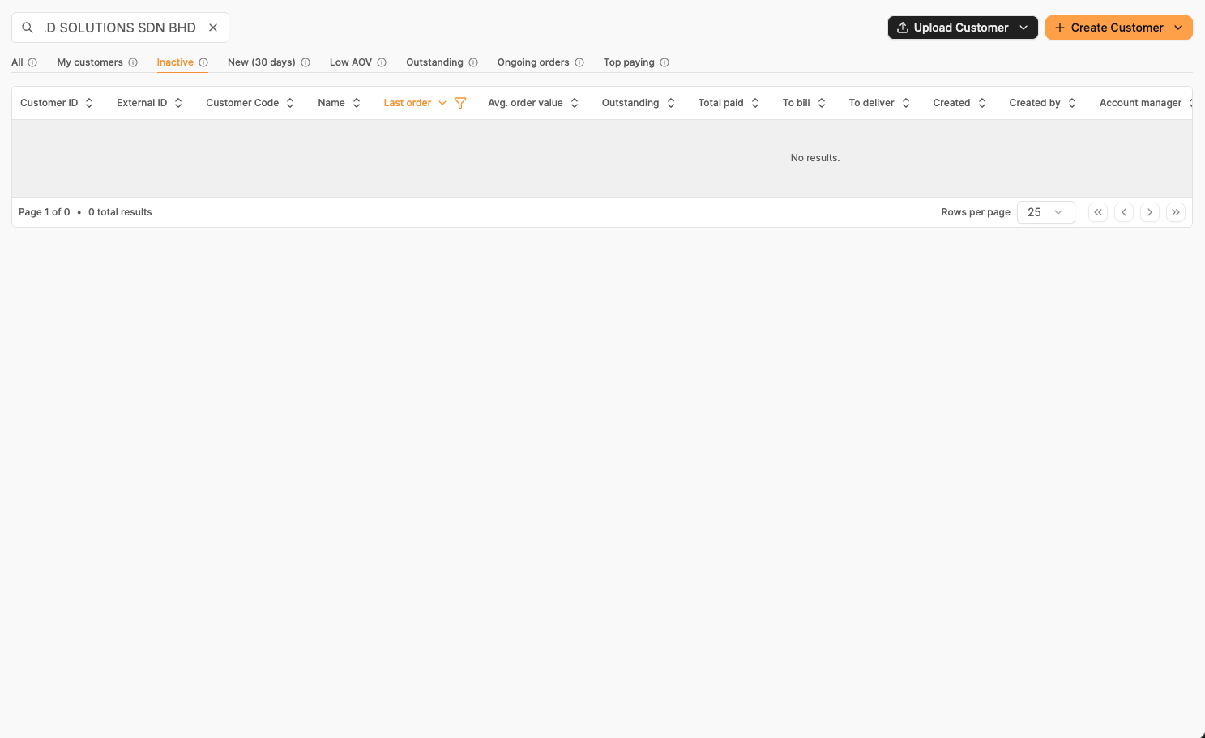
https://maia-fe-dalson.vercel.app/sales/customer-purchase-orders/CPO-2026-00022
Description:
In client db, the customer name is not fully named properly, missing sdn. Bhd.
When extracting the customer name with sdn bhd, if fail to do so

2. CPO 45
https://maia-fe-dalson.vercel.app/sales/customer-purchase-orders/CPO-2026-00045
Rank as 2nd in the top candidates, not confidence to match the item name
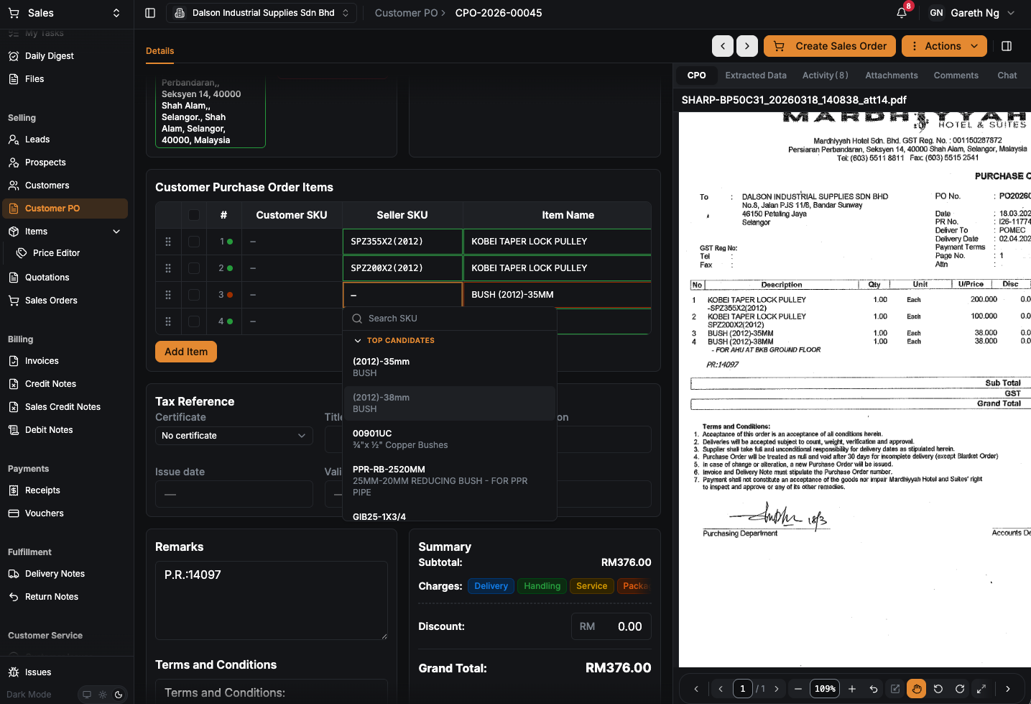

3. CPO 47
https://maia-fe-dalson.vercel.app/sales/quotations?page=1&page_size=25&sort=modified&order=desc&tab=all
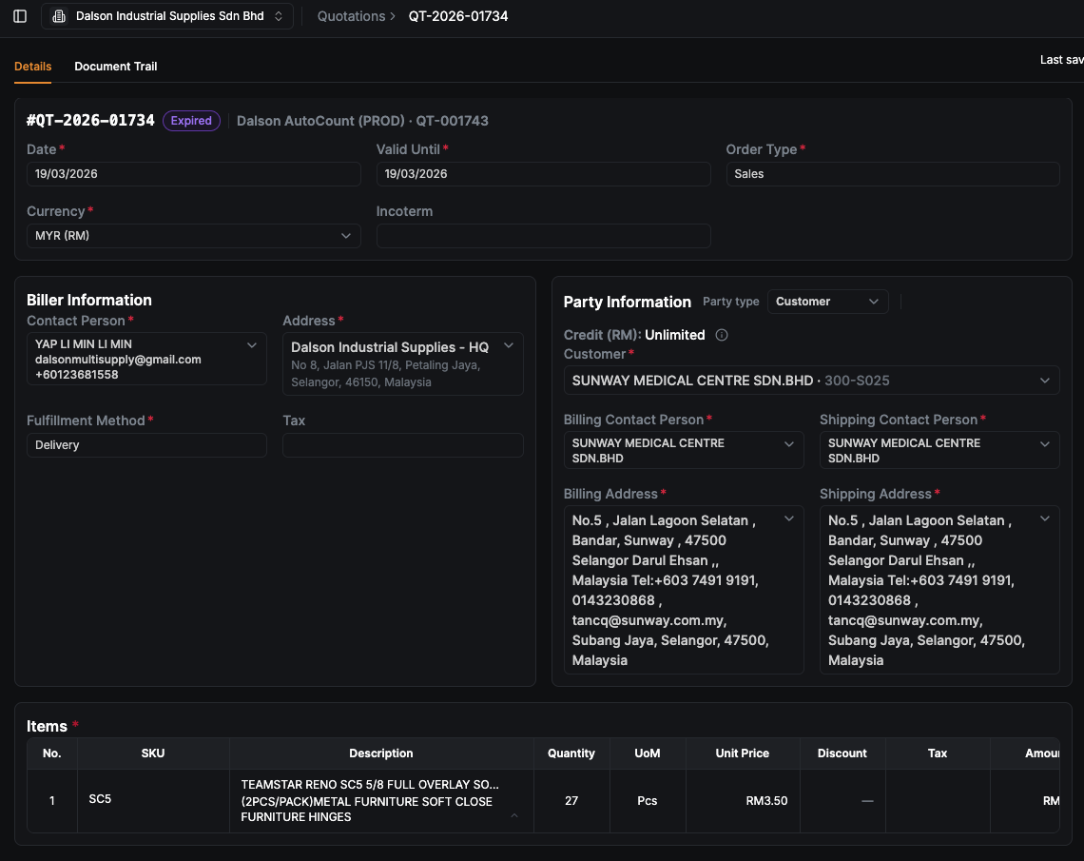

4. CPO 15
https://maia-fe-dalson.vercel.app/sales/customer-purchase-orders/CPO-2026-00015
False positive for 4th line items 3m
